**Project Description:**

Design and develop an academic management system using SQL. The project should involve three tables: StudentInfo, CourseInfo, and EnrollmentInfo. The aim is to create a system that allows for managing student information and course enrollment. The project will include the following tasks.

**Database Creation:**

1. Create the StudentInfo table with columns STU_ID, STU_NAME, DOB, PHONE_NO, EMAIL_ID, ADDRESS.:

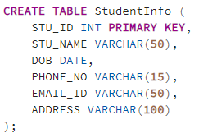

1. Create the CourseInfo table with columns COURSE_ID, COURSE_NAME, COURSE_INSTRUCTOR_NAME.:

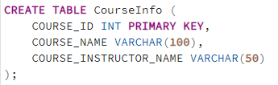

1. Create EnrollmentInfo with columns ENROLLMENT_ID, STU_ID, COURSE_ID, ENROLL_STATUS (Enrolled/Not Enrolled). The FOREIGN KEY constraint in the EnrollmentInfo table references the STU_ID column in the StudentInfo table and the COURSE_ID column in the CoursesInfo table.:

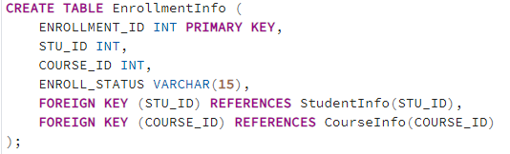

1. **Data Creation:**

Insert some sample data for StudentInfo table, CourseInfo table, EnrollmentInfo with respective fields.

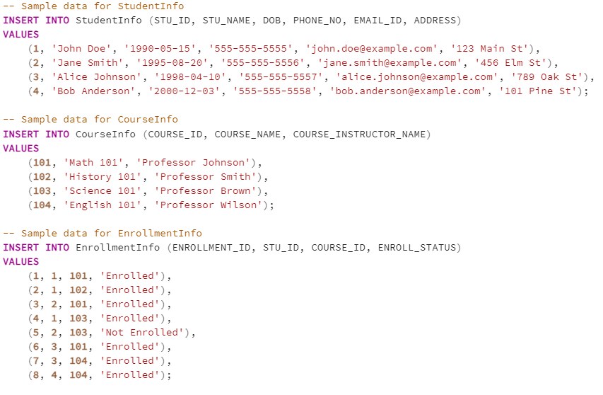

1. **Retrieve Student Information:**
2. Write a query to retrieve the student details, such as student name, contact information, and enrollment status.:

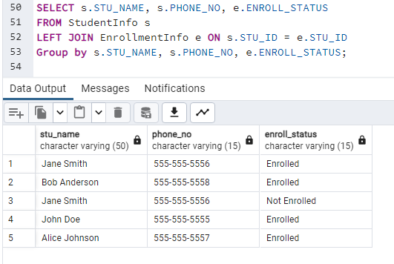

1. Write a query to retrieve a list of courses in which a specific student is enrolled.

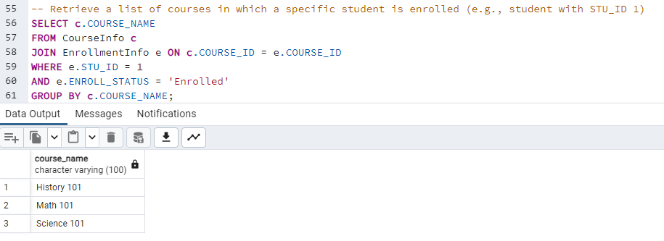

1. Write a query to retrieve course information, including course name, instructor information.

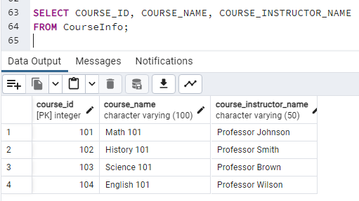

1. Write a query to retrieve course information for a specific course (e.g., course with COURSE_ID 101).:

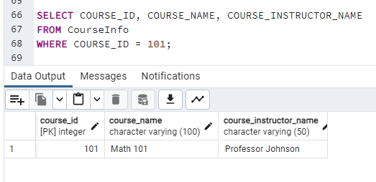

1. Write a query to retrieve course information for multiple courses (e.g., courses with COURSE_ID 101 and 102)

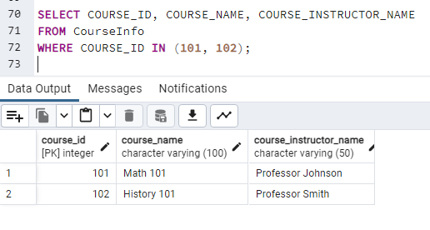

1. **Reporting and Analytics:**
2. Write a query to retrieve the number of students enrolled in each course:

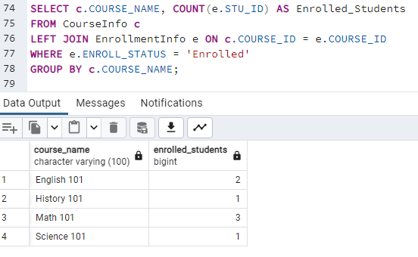

1. Write a query to retrieve the list of students enrolled in a specific course (e.g., course with COURSE_ID 101):

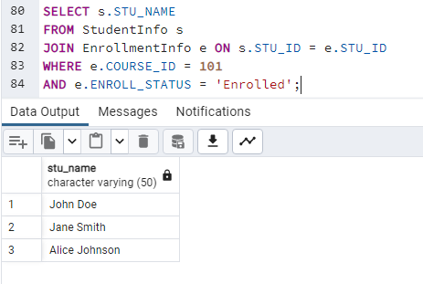

1. Write a query to retrieve the count of enrolled students for each instructor:

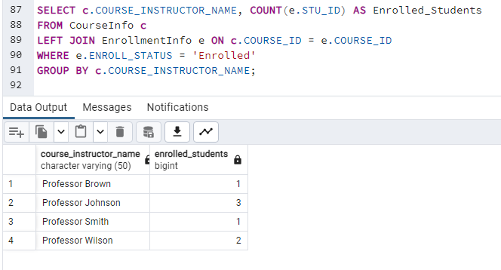

1. Write a query to retrieve the list of students who are enrolled in multiple courses.:

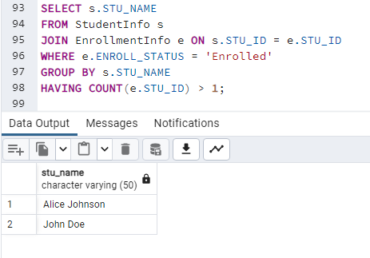

1. Write a query to retrieve the courses that have the highest number of enrolled students. (Arranging from highest to lowest).

